

НАЦІОНАЛЬНИЙ ТЕХНІЧНИЙ УНІВЕРСИТЕТ УКРАЇНИ

«КИЇВСЬКИЙ ПОЛІТЕХНІЧНИЙ ІНСТИТУТ імені Ігоря Сікорського»

ФАКУЛЬТЕТ ПРИКЛАДНОЇ МАТЕМАТИКИ

**Кафедра інженерії програмного забезпечення**

**Лабораторна робота №3**

з дисципліни

**«**Бази даних і засоби управління**»**

Виконав:

студент ІII курсу

ФПМ групи КП-71

Гришко Ю. І.

Перевірив: Петрашенко А. В.

Київ – 2019

**Ознайомлення з базовими операціями СУБД PostgreSQL**

*Завдання* роботи полягає у наступному:

1. Перетворити модуль “Модель” з шаблону MVC лабораторної роботи №2 у вигляд об’єктно-реляційної проекції (ORM).
2. Створити та проаналізувати різні типи індексів у PostgreSQL.
3. Розробити тригер бази даних PostgreSQL.
4. Навести приклади та проаналізувати рівні ізоляції транзакцій уPostgreSQL.

В ході роботи розроблено:

1. Логічну модель БД та Діаграму класів;
2. Функціонал програмного додатку;
3. Об'єктно-орієнтований програмний додаток роботи з БД "Магазин". Для взаємодії з БД використано ORM модуль SQLAlchemy.

**Варіант 2**

Логічна модель бази даних



**Зв’язки між сутнісними класами, сгенеровані за допомогою SqlAlchemy**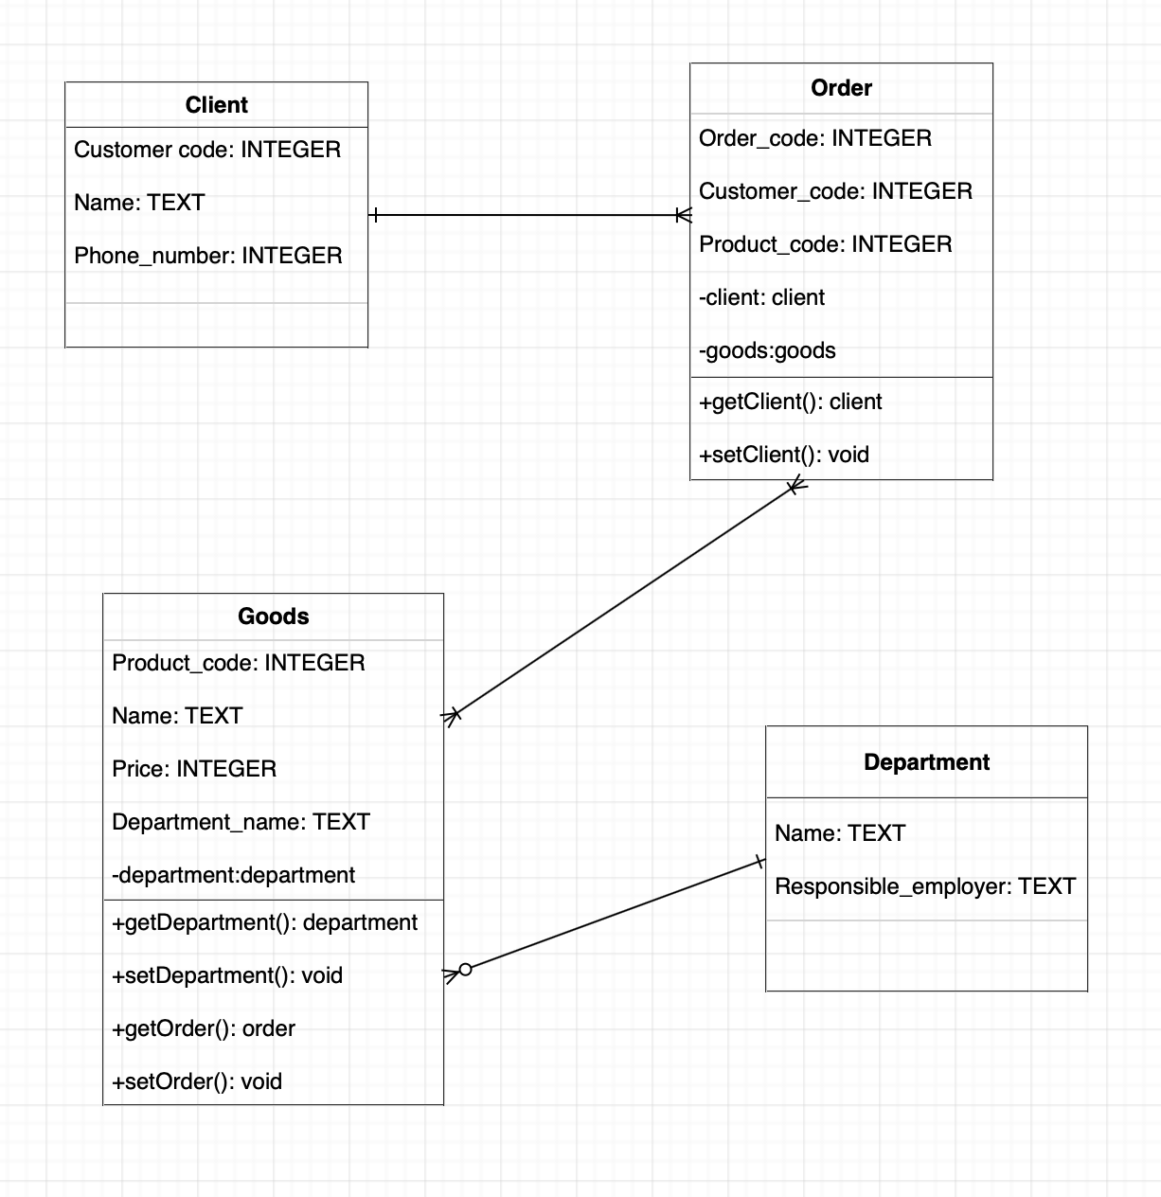

**Опис меню програми**

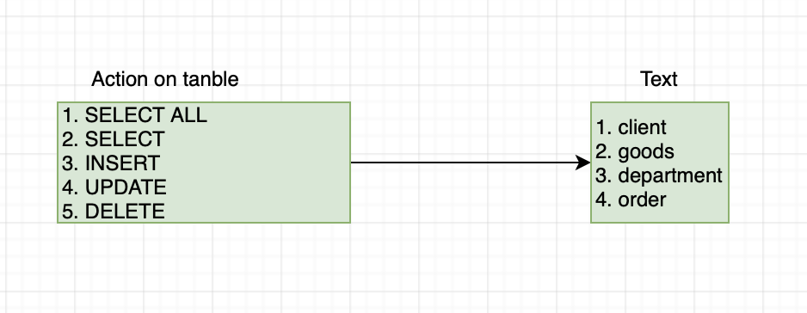

**Посилання на основні класи та методи програми**

1. Launcher
   1. Main метод
2. DatabaseHelper
3. DbInterface
   1. Вибрати всі елементи
   2. Вибрати елементи
   3. Оновити дані
   4. Записати дані
   5. Видалити дані
4. Model
5. Models(ORM класи)
   1. goods
   2. employee
   3. order
   4. department_of_goods
6. Controller
   1. Запуск меню програми
   2. Основне меню програми
7. View
8. Utils

**launch****er.py**

from database_helper import DatabaseHelper  
from controller import Controller  
from view import View  
from model import Model  
import class_generator  
  
def main():  
 if (is_need_generate()):  
 class_generator.generate_classes()  
  
 controller = Controller(View(), Model())  
 controller.start()  
 DatabaseHelper.close()  
  
def is_need_generate():  
 try:  
 print("Don't need to generate")  
 f = open("models.py")  
 return False  
 except IOError:  
 print("Trying to generate tables objects")  
 return True  
 #finally:  
 # f.close()  
  
if (__name__ == '__main__'):  
 main()

**databas****e_helper.py**

from sqlalchemy import inspect  
from sqlalchemy import Boolean, BOOLEAN  
from sqlalchemy.exc import NoInspectionAvailable  
import utils  
  
class DatabaseHelper(object):  
 # params  
 __session = None  
 __engine = None  
  
 #Using singleton pattern  
 def __new__(cls, *args, **kwargs):  
 if not hasattr(cls, '__instance'):  
 cls.__instance = super(DatabaseHelper, cls).__new__(cls)  
 return cls.__instance  
  
 #Using singleton pattern  
 @classmethod  
 def get_engine(cls):  
 if cls.__engine is None:  
 cls.__engine = engine = db.create_engine('postgresql://' + credentials.user + ':' + credentials.password + "@" +  
 credentials.host + ":" + credentials.port + "/" + credentials.db_name)  
 print("Created database engine ", cls.__engine)  
 return cls.__engine  
  
 #Using singleton pattern  
 @classmethod  
 def get_session(cls):  
 if cls.__session is None:  
 cls.__session = Session(cls.get_engine())  
 print("Database session opened")  
 return cls.__session  
  
 @classmethod  
 def close(cls):  
 cls.get_session().close()  
 print("Database session closed")  
  
 # Повертає інспектора для виконання запитів (engine - об'єкт для взаємодії з БД)  
 @classmethod  
 def __getInspector(cls):  
 return inspect(cls.get_engine())  
  
 @classmethod  
 def rollback_session(cls):  
 cls.get_session().rollback()  
  
 # Повертає список таблиць у БД (engine - об'єкт для взаємодії з БД)  
 @classmethod  
 def getListOfTables(cls):  
 inspector = cls.__getInspector()  
  
 table_list = []  
  
 for table_name in inspector.get_table_names():  
 if table_name is None: continue  
 table_list.append(table_name)  
  
 return table_list  
  
 @classmethod  
 def getTableColumns(cls, table_name):  
 inspector = cls.__getInspector()  
 return inspector.get_columns(table_name)  
  
 @classmethod  
 def get_primary_keys(cls, table_name):  
 inspector = cls.__getInspector()  
 return inspector.get_primary_keys(table_name)  
  
 @classmethod  
 def get_foreign_keys(cls, table_name):  
 inspector = cls.__getInspector()  
 return inspector.get_foreign_keys(table_name)  
  
 @classmethod  
 def fill_db_object(cls, model, inflator_object):  
 if not isinstance(inflator_object, object):  
 print("Aborting! This is object?! You are WRONG!")  
 return  
  
 db_object = model.create()  
 for key in inflator_object.keys():  
 try:  
 if isinstance(key.type, Boolean) or inspect(key.type, BOOLEAN):  
 setattr(db_object, key.name, utils.get_boolean_from(inflator_object[key]))  
 else:  
 setattr(db_object, key.name, inflator_object[key])  
 except NoInspectionAvailable:  
 setattr(db_object, key.name, inflator_object[key])  
 return db_object  
  
 @classmethod  
 def getTableObject(cls, table_name):   
 if table_name == 'goods':   
 return goods   
 if table_name == 'department':  
 return department  
 if table_name == 'order':   
 return order   
 if table_name == 'client':  
 return client

**class_generatory.py**

from database_helper import DatabaseHelper  
from sqlalchemy import VARCHAR  
  
  
def get_all_tables():  
 DatabaseHelper.getTableColumns("Book")  
  
  
def get_constraint(table_name, column_name):  
 primary_keys = DatabaseHelper.get_primary_keys(table_name)  
 foreign_keys = DatabaseHelper.get_foreign_keys(table_name)  
  
 if primary_keys.__contains__(column_name):  
 return ", primary_key=True"  
  
 for foreign_key in foreign_keys:  
 for referred_column in foreign_key['referred_columns']:  
 if referred_column == column_name:  
 return ", ForeignKey('" + str(foreign_key['referred_table']) + "." + str(referred_column) + "')"  
  
 return ""  
  
def generate_file_header():  
 class_text = ""  
  
 class_text += "from sqlalchemy import *" \  
 "\nfrom sqlalchemy.ext.declarative import declarative_base" \  
 "\nfrom sqlalchemy.orm import relationship" \  
 "" \  
 "\n\nBase = declarative_base()\n\n"  
  
 return class_text  
  
def generate_classes():  
 tables = DatabaseHelper.getListOfTables()  
  
 database_helper_content = ""  
  
 with open("database_helper.yandroid", 'r') as fileDb:  
 database_helper_content = fileDb.read()  
 fileDb.close()  
  
 with open("database_helper.py", 'w') as fileDb:  
 fileDb.write("from models import *\n")  
 fileDb.writelines(database_helper_content)  
 fileDb.writelines(generate_table_object_creation())  
  
 with open('models.py', 'w') as file:  
 file.write("#Generated by Horba Dima\n")  
 file.writelines(generate_file_header())  
 for table in tables:  
 file.writelines(generate_database_class(table))  
  
def generate_table_object_creation():  
 tables = DatabaseHelper.getListOfTables()  
  
 class_text = "\n @classmethod" \  
 "\n def getTableObject(cls, table_name):"  
  
 for table in tables:  
 class_text += " \n if table_name == '" + table + "':" \  
 " \n return " + table  
  
 print(class_text)  
 return class_text  
  
def get_str_column_type(type):  
 if isinstance(type, VARCHAR):  
 return "String"  
 else:  
 return str(type)  
  
def generate_database_class(table_name):  
 columns = DatabaseHelper.getTableColumns(table_name)  
  
 class_text = ""  
  
 class_text += "class " + table_name + "(Base):\n"  
 class_text += "\t__tablename__ = '" + table_name + "'\n"  
  
 for column in columns:  
 class_text += "\n\t" + column['name'] + " = Column('" + column['name'] + "', " + get_str_column_type(column['type']) + get_constraint(table_name, column['name']) + ")"  
  
 class_text += "\n\n\tdef __str__(self):" \  
 "\n\t\treturn '"  
  
 for column in columns:  
 class_text += column['name'] + "={" + column['name'] + "}, "  
  
 class_text = class_text[:-1]  
 class_text += "'.format("  
  
 for column in columns:  
 class_text += column['name'] + "=self." + column['name'] + ","  
  
 class_text = class_text[:-1]  
 class_text += ")"  
  
 class_text += "\n\n\tdef __repr__(self):" \  
 "\n\t\treturn str(self)"  
  
 class_text += "\n\n\t@classmethod" \  
 "\n\tdef get_columns(cls):" \  
 "\n\t\treturn ["  
  
 for column in columns:  
 class_text += table_name + "." + column['name'] + ","  
  
 class_text = class_text[:-1]  
 class_text += "]\n"  
  
 class_text += "\n\t@classmethod" \  
 "\n\tdef create(cls):" \  
 "\n\t\treturn " + table_name + "()\n\n"  
  
 print(class_text)  
 return class_text

**model****.py**

from base_dao import BaseDao  
from database_helper import DatabaseHelper  
import utils  
  
  
class Model(object):  
  
 def getTablesNames(self):  
 return DatabaseHelper.getListOfTables()  
  
 def getTableObject(self, table_name):  
 return DatabaseHelper.getTableObject(table_name)  
  
 def select_all(self, table_name):  
 model = self.getTableObject(table_name)  
 return BaseDao(model).select_all()  
  
 def select(self, table, object_to_find):  
 model = self.getTableObject(table)  
 baseDao = BaseDao(model)  
  
 mapped = utils.map_keys_and_values_from_obect(object_to_find)  
  
 if mapped is None:  
 print("Aborting! mapped is None")  
 return None  
  
 return baseDao.select(mapped['columns'], mapped['values'])  
  
 def fill_object(self, table_name, inflator_object):  
 model = self.getTableObject(table_name)  
 return DatabaseHelper.fill_db_object(model, inflator_object)  
  
 def insert(self, object_to_insert):  
 baseDao = BaseDao(None)  
 baseDao.insert(object_to_insert)  
 print("Inserted \t\t\t\tor Not ;)")  
  
 def update(self, table, object_to_update, updated_object):  
 model = self.getTableObject(table)  
 baseDao = BaseDao(model)  
  
 mappedFind = utils.map_keys_and_values_from_obect(object_to_update)  
 mappedUpdate = utils.map_keys_and_values_from_obect(updated_object)  
  
 baseDao.update(mappedFind['columns'], mappedFind['values'], mappedUpdate['columns'], mappedUpdate['values'])  
 print("Updated \t\t\t\tor Not ;)")  
  
 def delete(self, table, object_to_delete):  
 model = self.getTableObject(table)  
 baseDao = BaseDao(model)  
  
 mapped = utils.map_keys_and_values_from_obect(object_to_delete)  
  
 baseDao.delete(mapped['columns'], mapped['values'])  
 print("Deleted \t\t\t\tor Not ;)")  
  
 def rollback_session(self):  
 DatabaseHelper.rollback_session()

**model****s.py**

from sqlalchemy import *  
from sqlalchemy.ext.declarative import declarative_base  
from sqlalchemy.orm import relationship  
  
Base = declarative_base()  
  
class goods(Base):  
 __tablename__ = 'goods'  
  
 goods_code = Column('goods_code', INTEGER, primary_key=True)  
 goods_name = Column('goods_name', String)  
 goods_price = Column('goods_price', INTEGER)  
 goods_id = Column('goods_id', INTEGER)  
 department_name = Column('department_name', String, ForeignKey('department.department_name'))  
  
 def __str__(self):  
 return 'goods_code={goods_code}, goods_name={goods_name}, goods_price={goods_price}, goods_id={goods_id},' \  
 ' department_name={department_name},'.format(goods_code=self.goods_code,goods_name=self.goods_name,goods_price=self.goods_price,goods_id=self.goods_id,department_name=self.department_name)  
  
 def __repr__(self):  
 return str(self)  
  
 @classmethod  
 def get_columns(cls):  
 return [goods.goods_code,goods.goods_name,goods.goods_price,goods.goods_id,goods.department_name]  
  
 @classmethod  
 def create(cls):  
 return goods()  
  
class department(Base):  
 __tablename__ = 'department'  
  
 department_name = Column('department_name', String, primary_key=True)  
 department_id = Column('department_id', INTEGER)  
 responsible_employer = Column('responsible_employer', String)  
  
 def __str__(self):  
 return 'department_name={department_name}, department_id={department_id}, responsible_employer={responsible_employer},'.format(department_name=self.department_name,department_id=self.department_id,responsible_employer=self.responsible_employer)  
  
 def __repr__(self):  
 return str(self)  
  
 @classmethod  
 def get_columns(cls):  
 return [department.department_name,department.department_id,department.responsible_employer]  
  
 @classmethod  
 def create(cls):  
 return department()  
  
class order(Base):  
 __tablename__ = 'order'  
  
 order_code = Column('order_code', INTEGER, primary_key=True)  
 order_data = Column('order_data', DATE)  
 customer_code = Column('customer_code', INTEGER, ForeignKey('client.customer_code'))  
 product_code = Column('product_code', INTEGER, ForeignKey('goods.goods_code'))  
 order_id = Column('order_id', INTEGER)  
  
 def __str__(self):  
 return 'order_code={order_code}, order_data={order_data}, customer_code={customer_code}, product_code={product_code},order_id={order_id},'.format(order_code=self.order_code,order_data=self.order_data,customer_code=self.customer_code,product_code=self.product_code,order_id=self.order_id)  
  
 def __repr__(self):  
 return str(self)  
  
 @classmethod  
 def get_columns(cls):  
 return [order.order_code,order.order_data,order.customer_code,order.product_code,order.order_id]  
  
 @classmethod  
 def create(cls):  
 return order()  
  
class client(Base):  
 __tablename__ = 'client'  
  
 customer_code = Column('customer_code', INTEGER, primary_key=True)  
 name = Column('name', String)  
 phone_number = Column('phone_number', INTEGER)  
 client_id = Column('client_id', INTEGER)  
  
 def __str__(self):  
 return 'customer_code={customer_code}, name={name}, phone_number={phone_number}, client_id={client_id},'.format(customer_code=self.customer_code,name=self.name,phone_number=self.phone_number,client_id=self.client_id)  
  
 def __repr__(self):  
 return str(self)  
  
 @classmethod  
 def get_columns(cls):  
 return [client.customer_code,client.name,client.phone_number,client.client_id]  
  
 @classmethod  
 def create(cls):  
 return client()

**con****troller.py**

class Controller(object):  
  
 def __init__(self, view, model):  
 self.view = view  
 self.model = model  
  
 def start(self):  
 tables_names = self.model.getTablesNames()  
 length = int(len(tables_names))  
 self.view.print_main_menu(tables_names)  
 input_number = self.view.request_input()  
 try:  
 num = int(input_number) - 1  
 if num > length + 1 or num < 0:  
 print("Wrong choice, make another...")  
 print()  
 self.start()  
 else:  
 if num == length:  
 return  
 self.show_table_menu(tables_names[num])  
 except TypeError as error:  
 print("Wrong choice, make another...")  
 print()  
 self.start()  
  
  
 def show_table_menu(self, table_name):  
 self.view.print_table_menu(table_name)  
 table_object = self.model.getTableObject(table_name)  
 input_number = self.view.request_input()  
 try:  
 num = int(input_number)  
  
 if num == 1:  
 result = self.model.select_all(table_name)  
 print(result)  
 print()  
 self.show_table_menu(table_name)  
 return  
  
 if num == 2:  
 filled_object = self.view.request_input_object(table_object.get_columns())  
 result = self.model.select(table_name, filled_object)  
 print(result)  
 print()  
 self.show_table_menu(table_name)  
 return  
  
 if num == 3:  
 filled_object = self.view.request_input_object(table_object.get_columns())  
 db_object = self.model.fill_object(table_name, filled_object)  
 self.model.insert(db_object)  
 print()  
 self.show_table_menu(table_name)  
 return  
  
 if num == 4:  
 filled_object = self.view.request_input_object(table_object.get_columns())  
 updated_object = self.view.request_input_object(table_object.get_columns())  
 self.model.update(table_name, filled_object, updated_object)  
 print()  
 self.show_table_menu(table_name)  
 return  
  
 if num == 5:  
 filled_object = self.view.request_input_object(table_object.get_columns())  
 self.model.delete(table_name, filled_object)  
 print()  
 self.show_table_menu(table_name)  
 return  
  
 if num == 6:  
 print()  
 self.start()  
 return  
  
 except TypeError as error:  
 self.model.rollback_session()  
 print("Wrong choice, make another...", error)  
 print()  
 self.show_table_menu(table_name)

**view****.py**

import pandas as pd  
  
  
class View(object):  
  
 def request_input(self):  
 print("It's time to make your choice: ")  
 return input()  
  
 def request_input_object(self, columns):  
 inputed_object = {}  
 print("Let's fill some objects: ")  
 for column in columns:  
 print(column.name + " = ")  
 value = input()  
 if str(value) == "": continue  
 inputed_object[column] = str(value)  
 return inputed_object  
  
 def print_main_menu(self, tables_names):  
 index = 1  
 for table_name in tables_names:  
 print(str(index) + ". " + str(table_name))  
 index += 1  
  
 print()  
 print(str(index) + ". Exit")  
  
 def print_table_menu(self, table_name):  
 print("-------------------------------- " + str(table_name) + " --------------------------------")  
 print("1. SELECT ALL")  
 print("2. SELECT")  
 print("3. INSERT")  
 print("4. UPDATE")  
 print("5. DELETE")  
 print()  
 print("6. Back")  
  
  
 def show_fetched_result(self, db_object, result):  
 df = pd.DataFrame(result)  
 df.columns = db_object.columns  
 print(df)

**utils.p****y**

def map_keys_and_values_from_obect(obj):  
 if not isinstance(obj, object):  
 print("Aborting! U pass not objects, WTF?!")  
 return None  
  
 columns = []  
 values = []  
  
 for key in obj.keys():  
 columns.append(key)  
 values.append(obj[key])  
  
 return {"columns": columns, "values": values}  
  
def get_boolean_from(stuff):  
 try:  
 maybe_nmber = int(str(stuff))  
 return maybe_nmber == 1  
 except TypeError:  
 # definitely not number ;)  
 try:  
 maybe_string = str(stuff)  
 return maybe_nmber.lower() == "true"  
 except TypeError:  
 #FUCK IT  
 return False

**Досліди з індексацією**

**Створення тригера**